Job Consultant in Community General Adult Psychiatry

CANDIDATE INFORMATION PACK
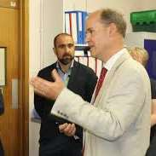
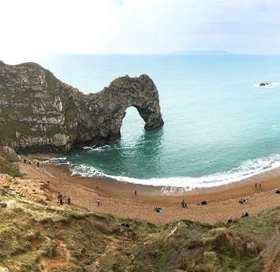
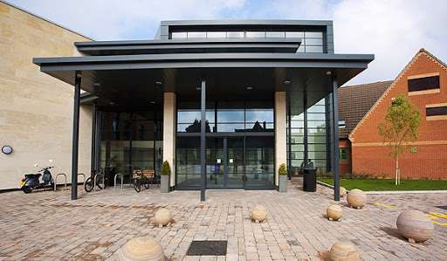

Contents

- Introduction to Dorset HealthCare
- Where we are
- Who we are and who we serve
- Our vision and purpose
- What people say about us
- Our strategy
- Trust Services in 2023
- The role
- How to apply

1. Introduction to Dorset HealthCare

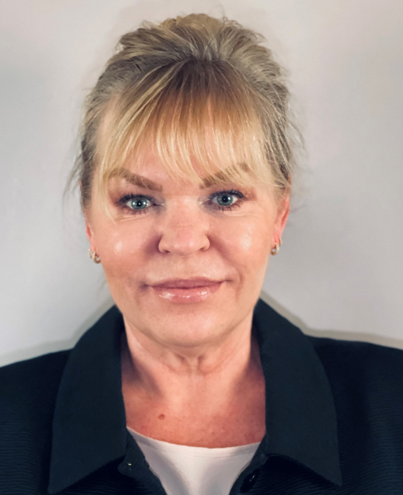
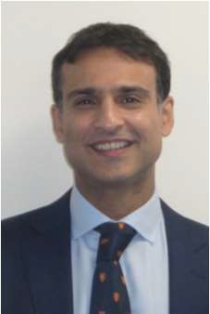

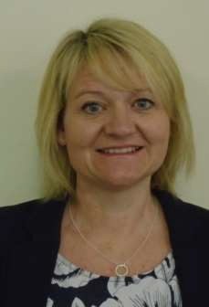

Kris Dominy

Chief Operating Officer / Deputy CEO

Patients are at the heart of everything we do and to do that well, we need likeminded clinical leaders who work hand in hand with operational leaders to deliver the best possible care.
Dr Faisil Sethi

Chief Medical Officer

Quite simply, we like to do things differently, and be innovative.

It is all about making a real difference to the lives of our communities, and you will work closely with multiprofessional colleagues across our integrated system.
We want colleagues who are passionate and want to lead their areas of expertise.
Dawn Dawson

Acting Chief Executive

Officer
As a key partner within the Dorset Integrated System we want to make our clinical services ‘Better Every Day’.
We want to work with advanced clinicians who are keen to collaborate with others, so if you have the desire to get involved in improvement and want to be part of something special then Dorset HealthCare is the place to be.

Matthew Metcalfe

Chief Finance Officer
We are committed to continuously improving the quality of outcomes for patients, supporting people live healthier lives, and being a great place to work. Our digital strategy is central to achieving this, and the CIO is key in delivering our success

Nicola Plumb
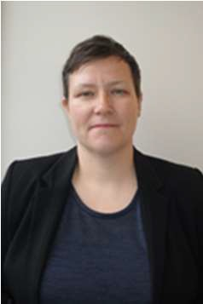

Chief People Officer and Director of Strategy
We want our staff to thrive as part of a compassionate and proactive community serving our patients and service users. We offer development opportunities and space to advance your career, with flexible and family- friendly working so everyone can be at their very best.

2. Where we are

Dorset is in the south of England and is famous for its coastline with award winning blue flag beaches and stunning countryside including the Jurassic Coast, a UNESCO World Heritage Site which spans the county’s coastline.
The south is one of the sunniest places to live in the UK with around 1600 hours of annual sunshine and an above average temperature in the summer.
Dorset is well connected to London and other areas of the country with good road and rail links.
The choice of state and independent schools is abundant and a number are ranked highly on national lists.
Bournemouth University with its growing campus and innovative academic buildings is in the top 100 UK rankings.

Dorset has something for everyone, vibrant towns and peaceful villages, and offers plenty of activities for the whole family both land and sea based.

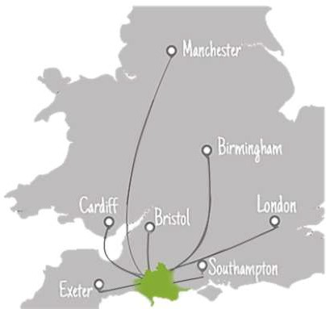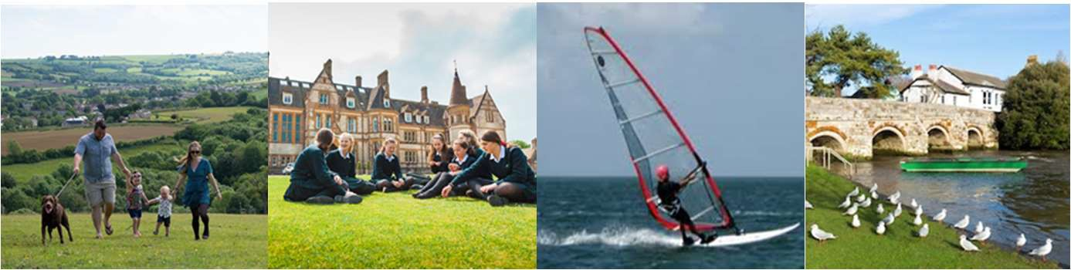
Links to:

3. Who we are and who we serve

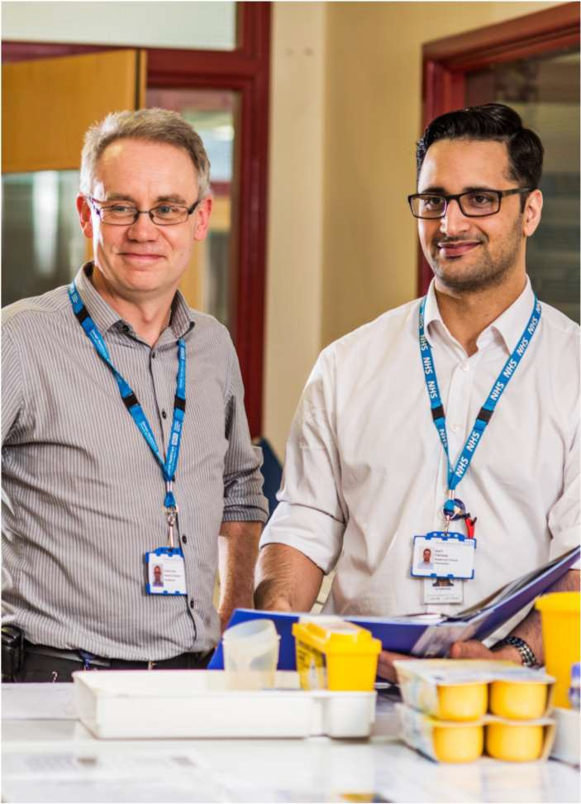
Dorset HealthCare University NHS Foundation Trust was rates outstanding by the CQC in July 2019.
services on the Our Dorset (Integrated Care System) website.

With a budget of £292M per year, we have around 6,300 staff working hard to provide physical, mental health and learning disability services to nearly 800,000 residents of Dorset, plus some in Hampshire.

We provide a comprehensive range of services for people of all ages, both in the community and in inpatient settings. You can find more information on our website.

You can find out more about the vision for health and care
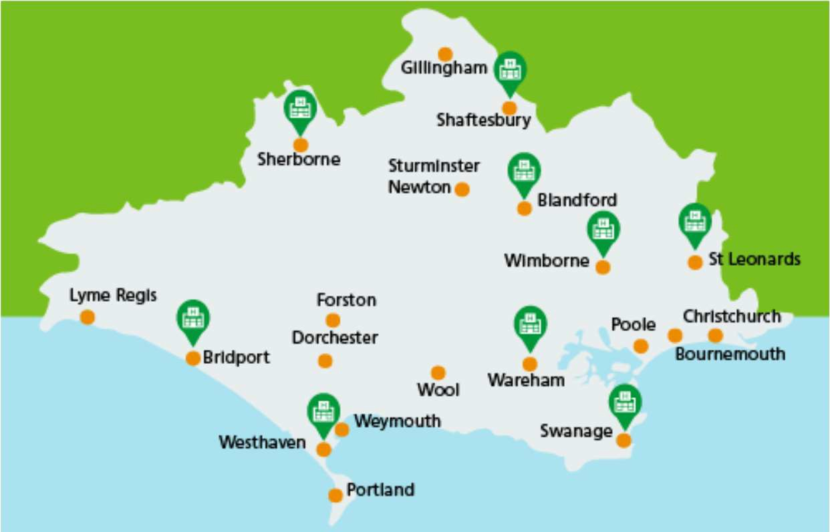

4. Our vision and purpose

Our vision is to be Better Every Day through excellence, compassion and expertise in all we do. And our mission is to provide integrated healthcare services that support people to make the most of their lives.

For our patients, that means person-centred care that gives them the best possible experience and outcomes.

For our staff that means being empowered and supported to be the best they can be, with the best possible experience and rewarding careers.

We believe that every day even the smallest changes mean we can be better for each other and the people we serve.

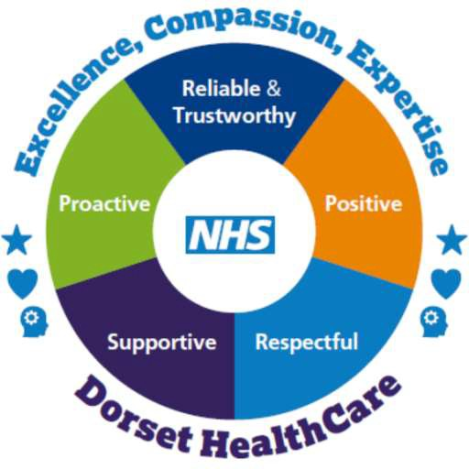

5. What people say about us

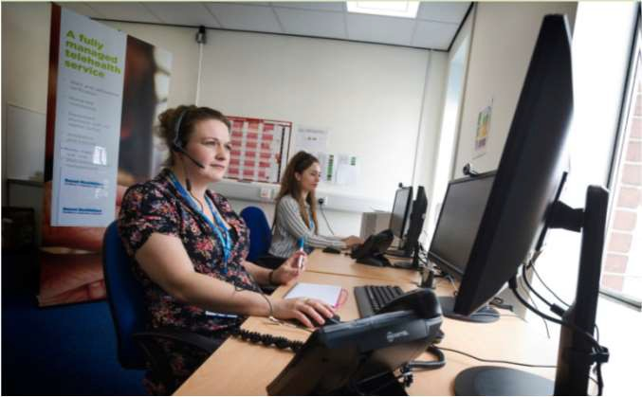
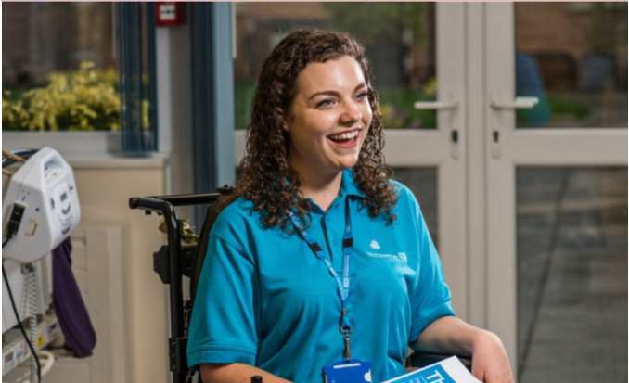
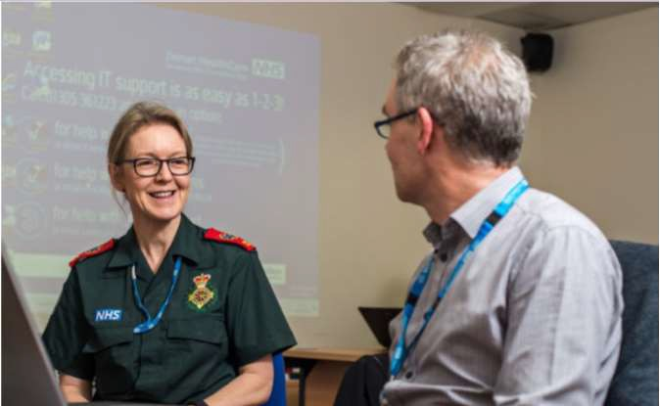
Patients
“Cared about me in a way that gave me confidence.”
“Very supportive - made a huge change to my life and has taught me skills that I will continue to use.”
“All the staff are welcoming and courteous and seem genuinely interested in your wellbeing.”
Patients’ comments in the Friends and Family Test
Staff
“I immensely enjoy my role and being able to deliver quality care direct to patients and support staff. The organisation encourages positive leadership and for staff to be responsible and accountable.”
Member of staff in the NHS Staff Survey
Volunteers
“It’s an interesting experience, very varied. Patients seem so pleased to have someone to talk to, which to me is what volunteer visiting is all about.”
Trust volunteer
Partners
“We share similar values and beliefs in that both organisations are committed to the communities they serve and to constantly strive to improve healthcare in the local area. We are delighted to have such a constructive and positive working relationship with Dorset HealthCare.” Prof Stephen Tee
Bournemouth University

6. Our strategy

In 2019 we agreed our strategic ambitions and priorities:

  - Best Place to work
  - Outstanding quality Services
  - Healthy Lives
  - Maximising Value and Sustainability

This over-arching approach is supported by a number of more detailed strategies including but not limited to:

- Quality
- Workforce
- Clinical
- Digital
- Estates
- Finance
- Engagement

We will need to consider how the changes we’ve made as a result of the COVID-19 pandemic will influence these ambitions and the way we shape our future.

To read and review our Strategies, Plans and Reports please take a look at our website
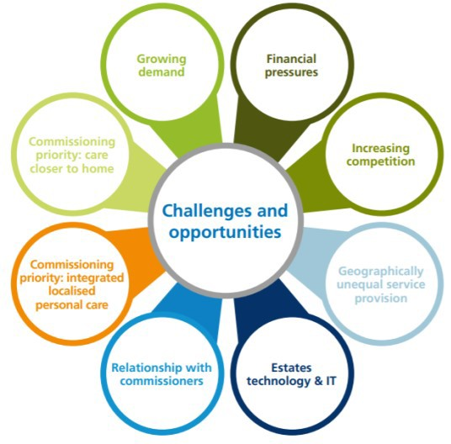

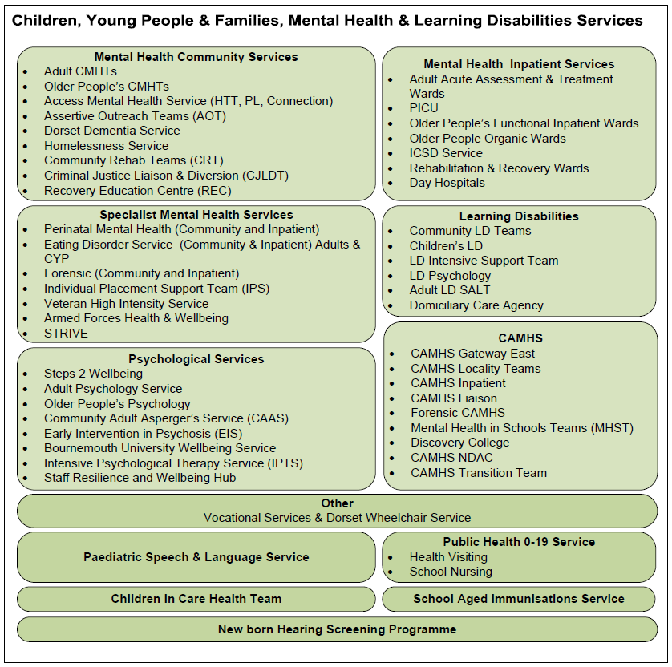
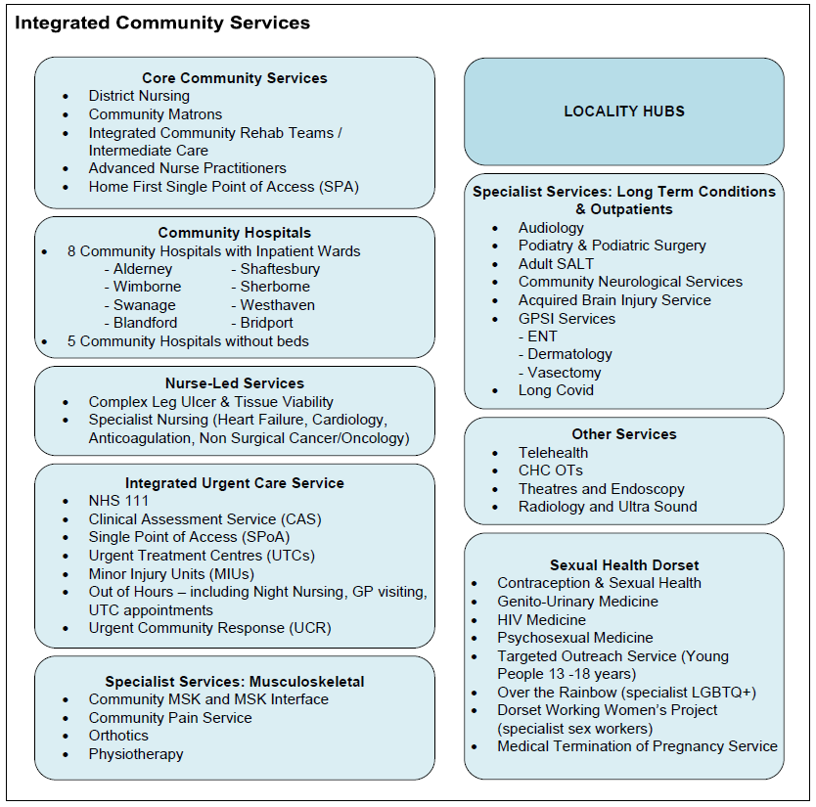
7. Trust Services in 2023 (provisional)

The Trust’s mental health and physical healthcare services are organised in the following way:-
7.1 Organisation of Clinical Services

Integrated Community Services. Provide both admission avoidance and supported discharges working closely with Acute, Primary Care and Social Care Services. Care is coordinated through Locality Hubs / MDTs including the deployment of telehealth were appropriate, whether receiving discharge referrals through the SPA or admission avoidance referrals via local Primary Care Networks. Our eight Community Hospitals, with inpatient wards,
work collaboratively to ensure effective and timely transfer from Acute services and step up admissions with a focus on rehabilitation and supporting the population of Dorset. Nurse-led services provide specialist care.

Integrated Urgent Care Services. DHC provides the 111 telephone and online services for Dorset and associated Clinical Assessment Services (CAS,which comprises telephone triage and consultation, treatment through our minor injury units and urgent treatment centres, urgent community response, GP home visits, night nursing, prison visits and remote support to the CAS as well as single point of access (SPoA) services to handle onward referrals.

Specialist Services. Covering long term conditions, and now including Post- Covid services, DHC operates outpatient services and MSK clinics across Dorset.

Community Adult Mental Health Teams. There are five large locality community mental health teams within East Dorset: Poole, Bournemouth West, Bournemouth East, Christchurch & Southbourne, Wimborne and Purbeck.
Within these large multi-consultant teams, there are individual consultant led sector teams but more specialist care, for example emergency care and care for some particular patient groups, can be provided teamwide as appropriate. In West Dorset there are three locality community mental health teams; North Dorset, Dorchester & Bridport and Weymouth and Portland.

Mental Health Inpatient Care. The service is planned such that all new admissions are admitted first to one of the acute admissions units. The Home Treatment service functions as the gate-keeper for inpatient care. Patients are either discharged from the Acute Assessment Unit back to their CMHT or to the Home Treatment Team or if their illness requires a longer period of care, they will move to one of the treatment wards.

7.1 Organisation of Clinical Services (cont)

Mental Health Inpatient Rehabilitation. There is an inpatient rehabilitation and recovery service with inpatient beds at Nightingale House, Alumhurst Road, Bournemouth and in the West of the county at the Glendenning Unit. The rehabilitation service works closely with the Assertive Outreach teams to facilitate discharge when appropriate for those patients with the most severe and enduring mental illnesses.

Mental Health Home Treatment Team. There are two Home Treatment Teams (HTT) for East Dorset and for West Dorset. They provide alternative to hospital admission for people over the age of 18 years across the county and accept referrals from CMHTs, Psychiatric Liaison Services, The Connection Service and from inpatient units.

Mental Health Specialist Teams. There are specialist inpatient and community teams in place covering the subspecialties which include:-
  - Early Intervention in Psychosis Service
  - Assertive Outreach Teams
  - Forensic Team (including inpatient Low Secure Unit and a Community Forensic team)
  - Perinatal Service
  - Eating Disorders Service
  - Liaison Services at Royal Bournemouth Hospital, Poole Hospital and Dorset County Hospital, Dorchester
  - Community Adult Asperger’s service
  - CAMHS
  - Learning Disabilities service
  - Adult Learning Disabilities service
  - Access Mental Health – Connections, The Retreats and Front Rooms

Children, Young People & Family Services. There are specialist teams working across Dorset to provide:-
Public Health Services (age 0-19) School Aged Immunisations Service Sexual Health Services
Paediatric Speech & Language Service Children in Care Health
New born Hearing Screening

7.2 Organisation of Digital Services

The Trust’s Digital services comprise a comprehensive range of services to deliver, improve, manage and support the Trust’s IT systems and underlying infrastructure, and are organised in the following way:-

- Service Desk and Technical Support. A single point of contact for all requests, queries and issues (faults or problems) concerning Trust-provided IT equipment; mobile devices; applications; clinical systems; smartcards and any internal development provided.
- Infrastructure and Procurement. This team provides and maintains all IT hardware, servers and network and offers support for all IT equipment. A single telephony system operates across all Dorset HealthCare sites with softphone functionality and traditional handsets available as needed. Working alongside Procurement colleagues, this team will be sure to gain best value whilst ensuring the most appropriate equipment is used for the right job.
- IT Solutions and Development. A team of application specialists work with users to set up and configure third-party applications in use at the Trust to ensure they meet service needs, and developers provide solutions built in- house. This team is also responsible for the Trust’s integration engine which is where we can take information from and to applications to prevent the need for double entry of data.
- IT Change, Projects, Initiatives, and Ideas. All requests are handled centrally to enable the team to work with users to get the right tools and be sure that any initiative works within the Trust’s wider Digital Strategy and technical standards. If a request is large enough, and requires project co- ordination, programme and project staff may provide help and resource.
- IT Clinical Support. A multi-disciplinary team of clinicians work to ensure changes and projects maintain a clinical focus and that the challenges of clinical working are fully recognised and embedded in any digital transformation work. This team leads on IT clinical governance, systems transformation and assurance of digital systems and technology, as required under the Health & Social Care Act 2012.
- Digital and Technology Training and Development. With a blended approach, through the design and delivery of a portfolio of training and development tools and events, this team provides training and coaching on a variety of systems, software and technology.
- IT Security. Working across the Trust to help colleagues understand the shared responsibility for us all to keep systems safe and secure, ensuring risks are understood and managed, and ensuring all staff know where to go for help, advice and guidance.

9. How to apply

To apply please visit www.jobs.nhs.uk
For further information about joining Dorset HealthCare, please visit https://www.dorsethealthcare.nhs.uk/work-for-us

We would welcome the opportunity to meet with any interested candidates prior to the interviews or submission of an application.

If you would like a pre-application conversation with members of the Mental Health & Learning Disabilities Leadership Team at Dorset HealthCare, you can do so via the contact links below.

Chief Medical Officer Dr Faisil Sethi
Contact Julie Street (Executive PA to the Chief Medical Officer) on 01202 277011 or via email to julie.street3@nhs.net

Chief Operating Officer: Kristin Dominy
Contact Debbie Ambrose (Executive PA to the Chief Operating Officer) on 01202 277163 or via email to debbie.ambrose@nhs.net

Acting Chief Executive Officer Dawn Dawson
Contact Michelle McKirdy (PA to the Acting Chief Executive Officer) on 01202 277010 or via email to m.mckirdy@nhs.net

Deputy Chief Medical Officer: Dr Sudipto Das
(Mental Health and Learning Disabilities)
Contact Liza Ward (PA to the Deputy Chief Medical Officer)
on 01202 611956 or via email to dhc.patodeputymedicaldirectors@nhs.net

Deputy Chief Medical Officer: Dr Andrew Dean
(Community Hospital and Physical Health Care Services)
Contact Liza Ward (PA to the Deputy Chief Medical Officer)
on 01202 611956 or via email to dhc.patodeputymedicaldirectors@nhs.net

Acting Chief Nursing Officer Cara Southgate
Contact Michelle McKirdy (PA to the Acting Chief Nursing Officer on 01202 277010 or via email to m.mckirdy@nhs.net

Service Director: Rachel Small
(Mental Health and Learning Disabilities)
Contact via email to dhc.patomentalhealthdirector@nhs.net

Service Director: Jane Elson
(Integrated Community Services)
Contact via email to dhc.patomentalhealthdirector@nhs.net
Clinical and Medical Leadership

